ASSESSING THE HEALTH OF RIVERS

Dr Cecilia Medupin
Introduction
Of the world’s water 97.75% is seawater and 2.24% in glaciers; therefore, the freshwater that we rely on for drinking and survival consists of only 0.009% in lakes, and just 0.0001% in rivers. Keeping our freshwaters healthy and clean is therefore vitally important. This activity focuses on river, the quality of which could be affected by various sources of pollution including effluent from industries (oil and toxic chemicals), non-direct source of pollution such as leakages, sewage, combined sewer overflows, runoff from roads, and agricultural activities (fertilisers and pesticides). Other causes of damage to rivers can also be attributed to increased urbanisation and the construction of dams and canals which increase water flow. Since water plays a critical role in ecological, domestic and economic activities, it is important that rivers are maintained and regulated. The importance of maintaining clean river systems is now recognized at the national and international level. For example, in the European Union, the Water Framework Directive seeks to ensure that all sources of water are in “good” ecological condition. In England, the Environment Agency monitors the quality of our rivers using the biological indicators that live in them as well as chemical analysis. This activity is designed to give you a taste of how biological indicators such as invertebrate populations can be used to monitor freshwater quality and to determine a river’s ecological status.

RIVER ASSESSMENT
- Most river pollution is caused by the addition of organic material which is mainly sewage but can be food waste or farm effluent. The organic matter is fed on by bacteria and other microorganisms and these use up the available oxygen. In unpolluted rivers there is a high level of dissolved oxygen, and a wide diversity of aquatic invertebrates. However, as oxygen levels are reduced fewer invertebrate species are able to survive.

- A macroinvertebrate is the term used for invertebrate fauna that can be captured by a 500µm net or sieve. This includes arthropods (insects, mites, scuds and crayfish), molluscs (snails, limpets, mussels and clams), annelids (segmented worms), nematodes (roundworms), and platyhelminthes (flatworms)

- These macroinvertebrates can be listed according to their ability to tolerate these low levels of oxygen, for example, stoneflies and mayflies can only live in high oxygen (unpolluted conditions) while blood ‘worms’ (actually an insect larva) and tubifex worms can thrive in very low oxygen conditions where other invertebrates are absent.

- Benthic macroinvertebrates (i.e. those dwelling on or in the sediments and on macrophytes) form a key component of the freshwater community. Many are herbivorous (plant eating), usually grazing on unicellular algae or (less commonly) macrophytes attached to the substrate or filtering phytoplankton out of the water. Others feed on dead organic matter (detritus). Some are carnivorous, feeding on other invertebrates and even small fish.

Assessment River Health Using Benthic Macroinvertebrates
We can use the number and type of taxa of macroinvertebrates in a stream as bioindicators of pollution. One way of doing this is to use a BMWP score. This is often used in Europe and adaptations of it have been proposed for other places e.g. Asia. In the case of BMWP score, this is based on the sensitivity to organic pollution (i.e. nutrient enrichment that can affect the availability of dissolved oxygen). This works by giving each family of aquatic organisms a score from 1 to 10. Those scoring highly (7-10) are sensitive to pollution, and their presence in a river indicates good conditions. Those with low (1-3) scores are tolerant to pollution, and their presence indicate highly polluted conditions.
In this workshop we will use a simplified BMWP score for a river. We take a sample of invertebrates and assign each type using their BMWP scores (see Recording Sheet on Table 2). For each type of organism (e.g. mayfly, score of 10) we add the scores if we found three different types of mayfly (with a score each of 10)-they would score 3 x 10 = 30). We then add up all the scores for each taxa to give a total BMWP score for our sample. However, we do not take into account the number of individuals of the same type in the sample – whatever the number, they only score once. We can then use the following Table 1 below to work out how polluted our river or stream is:
TABLE 1: Simplified BMWP score for activity
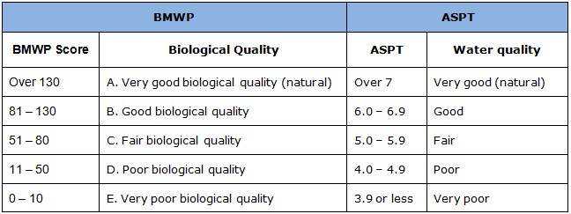
(from https://oart.org.uk/our-work/projects/water-quality/biological-monitoring)
++Note that we are using a slightly simplified BMWP score. For a full BMWP score we would have to work out all the different types of invertebrate to a high level of detail (identify to families). This can be very time consuming and needs quite a lot of expertise, so we are going to identify the invertebrates to major groups only.
You will also calculate the Average Score Per Taxon (ASPT) score. The ASPT equals the average of the tolerance scores of all macroinvertebrate families found, and ranges from 0 to 10. The main difference between both indices (i.e. BMWP and ASPT) is that ASPT does not depend on the family richness. ASPT is independent of sample size (being an average) and is less influenced by seasonal variations than the BWMP method and therefore gives an additional, more consistent index.
Note that the number of individuals within each group does not matter – if you find 1 individual of stonefly type ‘A’, that scores 10 - the same as 8 individuals of type A.
For example, if your sample had
2 types of cased caddisflies = score 7
1 type of freshwater shrimp = score 6
3 types of leech = score 3

A higher score for the Type/Taxa means it is the more sensitive to pollution. So if your final score is high then it indicates that the river is less impacted by pollution.
Table 2: RIVER RECORDING SHEET – BENTHIC INVERTEBRATES Figures from
https://www.nrem.iastate.edu/class/assets/aecl518/Data%20and%20Tools/IOWATER_advanced_benthic_key.pdf
Name | Figures of organism | Score per type/Taxa  (a) | Number  of different types (b) | Score
Stonefly (Plecoptera) | 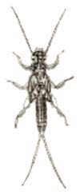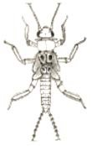 | 10
Mayfly(Ephemeroptera)  except Baetidae =4  & Damselflies  (Odonata) | 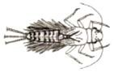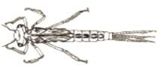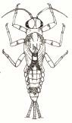 | 10
Cased Caddisfly  (Trichoptera) | 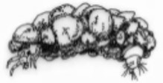 | 7
Freshwater Shrimp  (Amphipoda) | 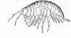 | 6
Caseless Caddisfly  (Trichoptera) | 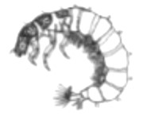 | 5
Flat Worm  (Planariidae) | 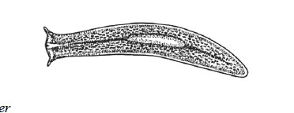 | 5
Water mite  (Acari) | 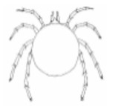 | 5
Beetle larva  (Coleoptera) | 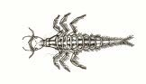 | 5
Crane Fly (Tipulidae) and Horse Fly Larva  (Tabanidae) | 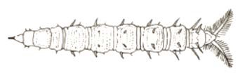  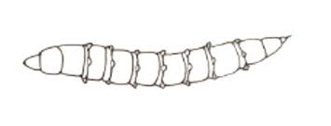 | 5
Black fly larva  (Simuliidae) | 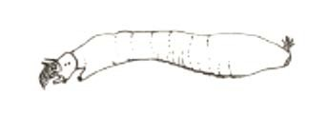 | 3
Leech  (Hirudinae) | 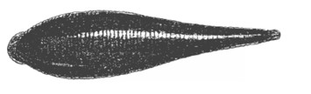 | 3
Snail  (Gastropoda) | 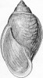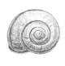 | 3
Total BMWP scores  ASPT |  |  |  | =add up the scores

Workshop exercise
The following benthic macroinvertebrates were identified and counted from two local UK rivers in London and at Leeds:
London: 10 leeches, 15 snails, 2 stoneflies, 35 freshwater shrimps, 3 flatworms, 25 caseless caddisflies and 2 damselflies
Leeds: 22 cased caddisfly larvae, 35 mayflies, 10 leeches, 4 snails, 7 stoneflies, 17 freshwater shrimps and 3 black fly larvae
[Note that the different types of organisms for individual taxa have not been included in this question]

Questions
- What are the total BMWP scores and ASPT for both locations? (ASPT score (i.e. total BMWP score divide by the number of taxa)

- Are there differences between your answers for both locations?

- From your score, what is the health of the river: very poor, poor, fair, good, or very good? …………………………………………. (refer to table 1)

